Sketch Jets

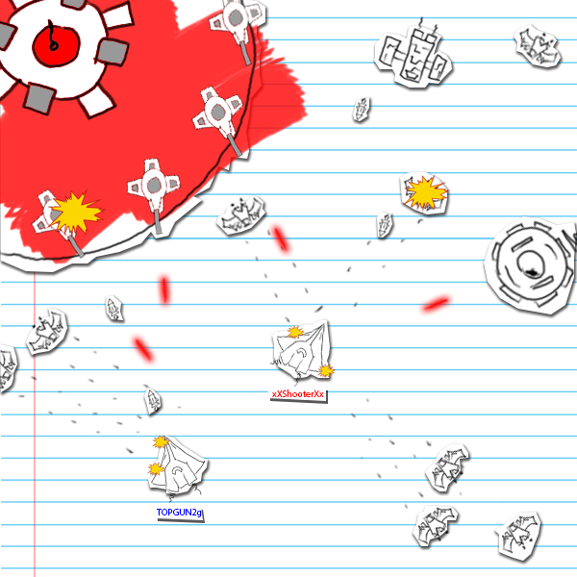

Static Light Studio

Benjamin Lovegrove, Daniel Ackroyd, Stewart Coates, Gary Reid, Wilson Tang

**CONTENTS:**

**Game Design**

**Concept 3**

**Core Mechanics 3**

**Gameplay Flow 4**

**Player Character 5**

**Controls 5**

**UI 6**

**ART 7**

**Weapons 7**

**Player Weapons 8**

**Enemies 8**

**Mini Boss 9**

**Technical Requirements 9**

**Project Management**

**Scope definition 10**

**Objectives of the project 10**

**Deliverables 10**

**Infrastructure 10**

**Project Management Methodology 11**

**Target audience 11**

**Schedule and Risk Management Plan 11**

**Game Design**

**Concept**

“A small section of the Sketch Universe has been taken over by an unknown alien fleet. It’s up to the two best Sketch fighter pilots to venture into their territory and reclaim the enemy planet bases, turning the invaders own weapons back on them.”

* 2D, top down, dual stick space shooter
* Co-op, vertical split screen
* A constant flow of spawning enemies increasing in number over the game.
* Planets as bases with turrets defending them. Objective is to destroy the turrets and capture the planets.
* Planets then change from red to a friendly color. Turrets respawn and aim for enemies instead of the player.
* Captured planets stop the player from being overwhelmed by increasing numbers.
* Once all planets are captures a multi-phase boss is spawned that the players must kill to win.
* Elements that require teamwork. (Reviving, Enemies will be overwhelming against a single player, 2 players speed up capture time, players at separate planets will double the planet enemy waves, possibly certain boss mechanics)
* Fast paced gameplay.
* Sketch aesthetic.

**Core Mechanics**

**Flying**

Controlled by the dual analog sticks. Will be achieved using translate (opposed to unity physics) for a responsive feel. There will be a set speed and no acceleration or deceleration.

**Shooting**

Player is able to fire a variety of weapons with various attributes. Used for defeating enemies and turrets.

**Player and Enemy health**

Players and enemies have a set amount of health. Collision with bullets reduces health by a set amount and 0 health means death.

**Reviving**

If one player dies the other player is able to revive them. It is done by being within a small range of the players dead space ship which starts a revive timer bar and takes a few moments.

**Planets with gravity affecting the players, enemies and bullets**

Planets all have gravity affecting a set area around them. Gravity drags in enemies, players and bullets in increasing amounts closer to the planet. This will be a pivotal part of gameplay as aiming and flying will both need to compensate for this.

**Capturing Planets**

Hovering above a planet starts a capture that takes a set amount of time. If both players are above the planet the capture speed is doubled. Captured planets will have friendly turrets on them that assist the player. Capturing planets is the main objective of the game. Once all of the planets are captures the Boss phase begins.

**Weapon drops**

Enemies will have a set % chance of dropping the type of weapon they use. Upon the player picking up this drop they are able to switch to this weapon for the rest of the level.

**Enemies**

There are various types of enemies that will attack the player in various ways and need to be killed. There will be a consistent flow of enemies and also additional waves when the player is within range of the planet. Enemies will always be spawned off screen.

**Points**

Points will be accumulated between the players and displayed combined at the top of the screen. The points will be a combination of a finishing bonus, enemy kills, time spent capturing and damage done to the boss minus the time played. Individual scores may be displayed at the end of the level.

**High Scores**

The top scores will be saved locally and be accessible from the main menu. They will be displayed using the names of both players and their combined score.

**Gameplay Flow**

* Spawn in sketch space.
* Enemies begin to approach and attack the players.
* Players fights off enemies as they search for planets.
* Destroy the planets turrets and hover over the capture point to occupy the planet.
* Destroyed planets turrets get rebuilt as your own and now aim at remaining enemy ships.
* Once a percentage of planets are captured Multi-Phase boss spawns and will continue to respawn with upgraded weapons with each certain percentage of planets captured.
* Level finishes upon re-capturing final planet then killing the multi-phase boss as he appears for the last time with much more armour, score screen is displayed.
* If one of the players die the other player can attempt to revive them while fighting off enemies.
* If both players die the level ends and scores and displayed.

**Player Character**

As a co-op there will be two player characters. Both are 2D top down space ships with slightly different looks but identical functionality. Your origin is unknown but your motivation is that you are trying to capture hostile planets from an unknown alien race.

The player has a health bar with a set health amount and a single life. The player will be able to take a fair amount of bullets but it will deplete quickly when overwhelmed.

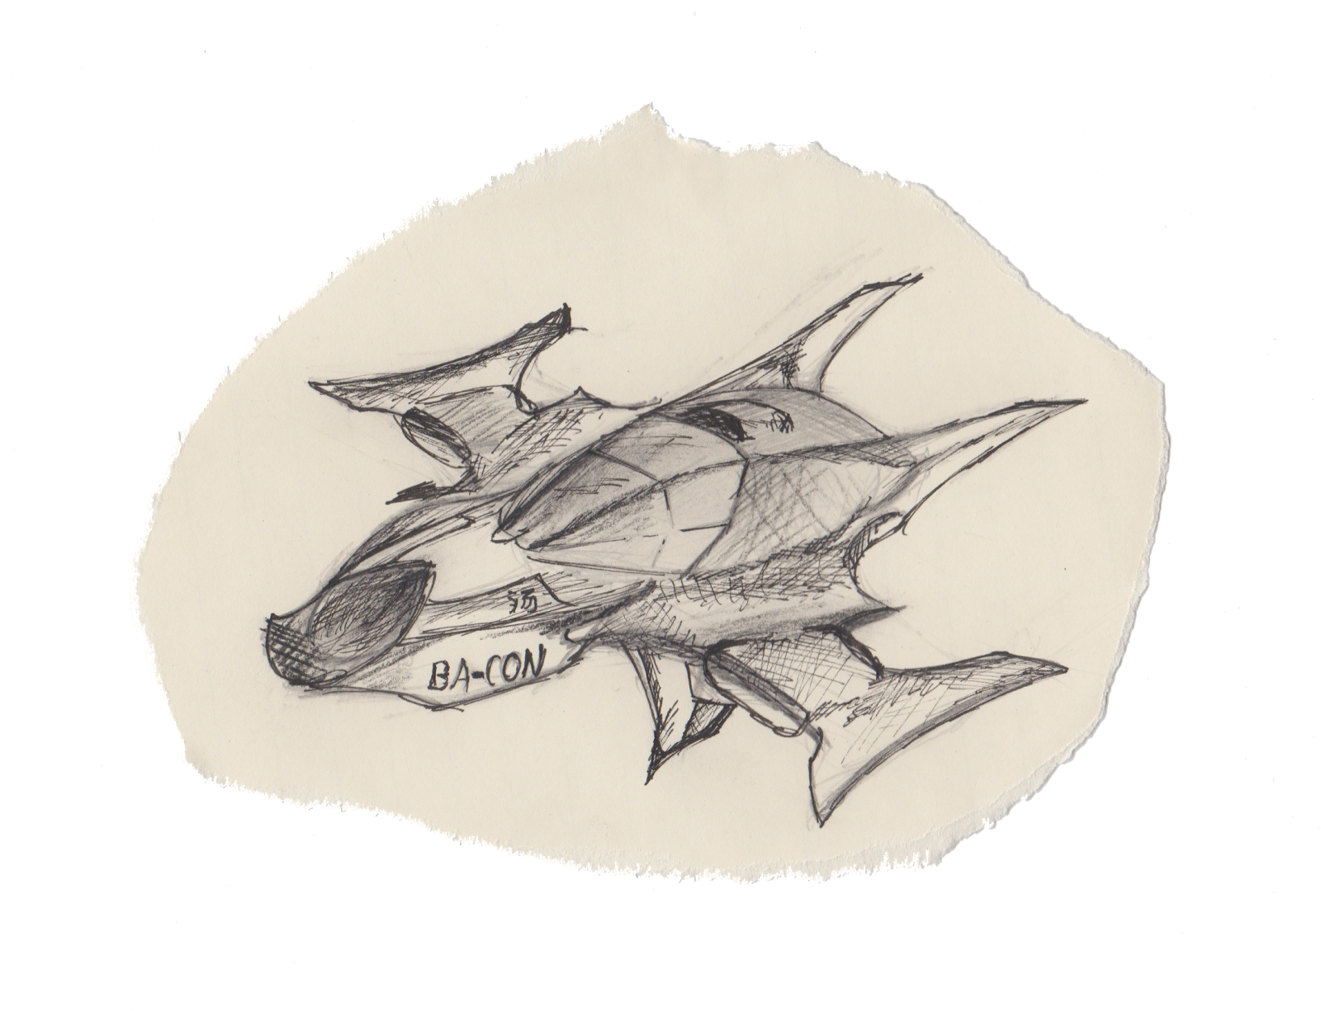

**Controls**

Dual Stick Shooter. Designed to be played with a controller.

Left Analog - Player movement in 2d space. There is no turning just 1-1 movement in any direction.

Right analog - Turn gun/Aim in a circle around the player.

Left Trigger - Fire weapon.

Button 2 - Change weapon.

**UI**

The concept for the UI is to further use the splashes of color for points of interest as well as keeping it simple. The most important aspects of the UI are the health, score, weapon and remaining planets.

The health bars are represented by strokes of highlight in the player’s respective color. The stroke is resized depending on the player’s health.

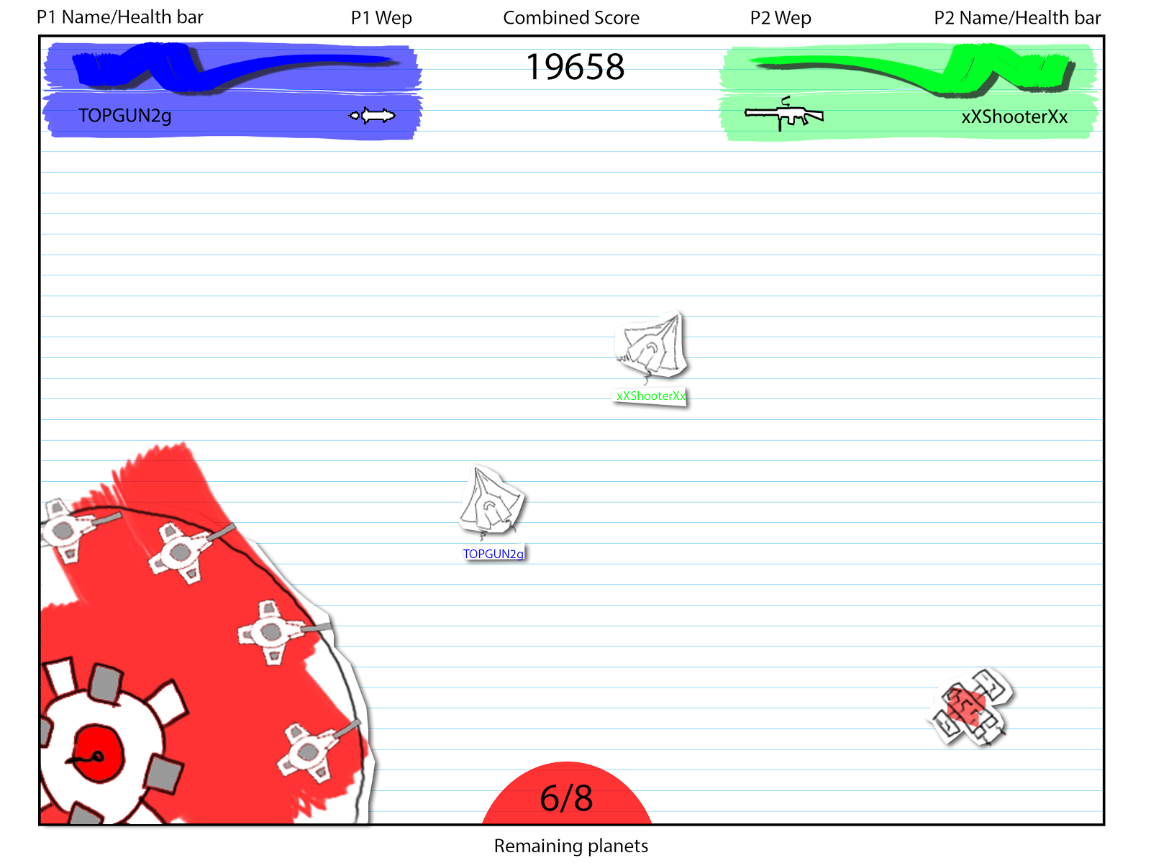

**Art**

* Sketch theme
* Static notepad background with the illusion of gameobjects as moving scraps of paper with sketches on them.
* “Highlighter” coloring used on key points and enemies so that friends, enemies and objectives are easily identifiable.
* The aim is for simple, intuitive and striking visuals.



**Weapons**

Enemies Health is represented by “Enemy Armour”

The player begins with a basic machine gun style weapon. Weapon upgrades/replacements are then dropped by enemies that use that specific weapon on a set % chance. Weapons are reset and recollected on each level start. Weapons are additively collected and your current weapon can be changed with the left trigger.

**Player Weapons**

**Starting machine gun.**

Rate of fire - Fast (several per second)

Bullet speed - Med

Damage - 10-20 (5-10 bullets per enemy)

**Drop - Rail Gun**

Laser weapon with high reload time. Single shot kill for most enemies.

Rate of fire - Slow (1 every 2 seconds)

Bullet speed - Fast

Damage - 200

Not affected by gravity

**Drop - Rocket Launcher**

Launches rockets that explode on impact with an aoe effect.

Rate of fire - Medium (1-2 per second)

Bullet speed - Slow

Damage - 70

**Drop - Laser machine gun**

Upgraded version of starting machine gun with higher damage.

Rate of fire - Same

Bullet speed - Same

Damage 20-30

Not affected by gravity

**Enemies**

**Mini-Drones**

Size: Small

Weapon: Single-Shot lasers, 2 second shot waiting time

Damage Taken: 2hp

Enemy Armour: 10hp (1 hit kills, with any gun)

Speed: Medium to High, on a scale of 0-1, 1 being the max acceptable speed, 0.7.

Spawn Rate: High

**Fighters**

Size: Medium

Weapon: Rockets, 2 second shot wait time (if possible shoot 2 at once?)

Damage Taken: 10 hp per rocket (or 5hp each if 2)

Enemy Armour: 200hp

Speed: 0.5

Spawn Rate: Medium

**Armoured Ship (Not a Mini Boss)**

Size: Large

Weapon: Rail Gun

Damage Taken: 35hp (Ships aim and fire is delayed by 1 second, allowing for it to only hit the player if they are stationary for too long)

Enemy Armour: 1000hp

Speed: slow

Spawn Rate: VERY low (make it occur once within the demo level)

**Turrets:**

Size: Medium

Weapon: Large Single Shot laser (1 per 2 seconds shot time)

Damage Taken: 5hp

Enemy Armour: 200hp

Speed: Stationary

Spawn Rate: 6-10 per planet depending on planet size

**Mini Boss**

Large boss that floats towards you and fires a certain type of weapon at you each phase. Once you destroy enough of the weapons attached to him he flies away off-screen where he stops and replaces them. He will return once more planets are captured. You can only hit one part of him to finally kill the multi-phase boss, but this may only be done after destroying the main weapon he has equipped on the final phase, making him defenseless and to be finished off.

(Very Satisfying feeling having a boss that is defenseless, you can savor the moment longer)

Size: Twice as large as the Armoured Ship (Very large)

Weapon: Multiple

Damage Taken: does same damage as is specified from the other enemy ships above for each weapon

Enemy Armour: 5000 HP for each phase, Final Phase 10,000 HP

Speed: VERY slow

Spawn Rate: Each phase occurs when a certain percentage of planets have been re-taken within the level. Final phase happens after final planet re-taken.

**Technical Requirements**

* Medium-high spec PC. (Windows, Mac, Linux)
* Playable with low specs however sections of high spawn rates may result in low frame rates.
* Gamepad controller.

**Project Management**

**Scope**

2-4 Minute single level demo for kickstarter.

2D Top down dual stick shooter.

2D Art assets.

Audio assets.

All functionality outlined in Core Mechanics.

Menu.

Score screen.

**Project Objectives**

The aim of this project is to create a solid 2-4 minute demo representative of the concept of the whole game.

The demo is the foundation of a kickstarter campaign and in this light the focus is to create as complete and bug free a level as possible over volume of content.

**Deliverables**

**Week 6**

Project documentation.

Risk Management document.

**Week 7**

GitHub Account access.

**Week 10**

QA Test plan.

**Week 12**

Complete game, data and asset files.

**Week 13**

Post-Mortem in class meeting.

**Infrastructure**

**File Sharing**

Google Drive

GitHub

Facebook

**Version control**

GitHub

**Engine and Development**

Unity

**Asset creation**

As required and preferred by team members.

**Project Management Methodology**

The team will be using a toned down version of the Agile/Scrum methodology. The reasoning behind this is that we feel the scrum methodology is best for our team and this project due to project size and similar skill level and specialization of team members.

**Alterations/specifications:**

* No Product Owner (collaborative vision).
* Team Leader/Scrum master: Benjamin Lovegrove.
* Week long sprints.
* Reviews weekly (Tuesdays 12-3pm).
* Daily facebook communication in place of daily standup meetings.

The reason for our alterations are due to a fairly clear vision of the end product due to the size of the project and completed document and also time constraints due to weekly classes.

**Target Audience and respective features**

**Retro Game Fans**

* Simple art style
* Dual stick shooter
* Arcade feel
* Somewhat faithful to original top down shooters but with a fresh concept

**Social Gamers**

* Co-op
* Simple mechanics that require teamwork and communication
* Fast paced action that ramps up for intense interaction with friends

**Steam Shoppers looking for some quick fun**

* Interesting, basic and vivid stylization for instant interest from screenshots
* Small file size (replayability vs content)
* Straight into the action gameplay (No narrative/tutorials)

**Other Considerations**

* Western
* All ages

**Schedule and Risk Management Plan**Find attached/in drive.